Star Trek:



Secret Domains

Written by: Mark Sickle

Storyline created by: Mark Sickle

Based on Gene Roddenberry’s “Star Trek”

This story, and all future stories, are written in grateful memory of the creator of the greatest space adventure ever created – Gene Roddenberry.

(2001)

Episode 1

The Mission: Parallel

Part One

Underway: 04/21/01

Prologue

- Somewhere near the Badlands
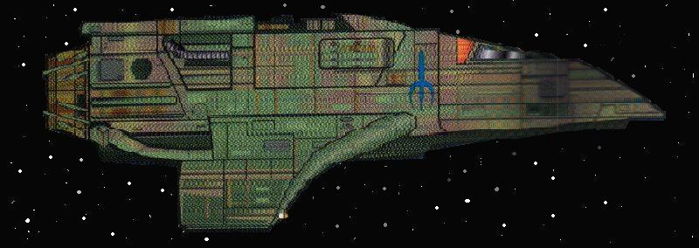
The utter silence in the command deck of the small raider craft was almost unnerving. Of the two men sitting there, though, it was only affecting one of them.
Nervously fidgeting, Tarran kept looking at his displays, then back at the viewscreen. Checking the sensors, then back at the viewscreen. He was beginning to get a little antsy. And annoying, his counterpart thought.
“How much longer is it going to be?” Tarran asked, sounding almost as if he were whining.
A sharp glance from over his shoulder caused Tarran to look away. “Any minute now,” Jax said. This was the one reason why Jax didn’t care for bringing the young, inexperienced runners with him on jobs like this. Tarran was a bright kid, that’s for sure, but he was also impatient and undisciplined.
“They should’ve been here by now,” Tarran said under his breath.
Jax sighed. “No. I know this Maquis - he’s not going to be late. He never is.” He fell quiet, and then added, “Especially, not with the offer we gave him.”
“I don’t like the Maquis. They’re dangerous – erratic.” Tarran whined again.
“Look, pal. Nobody likes these guys. They’re unpredictable. But we have a job to do here, so let’s just do it. And remember two things: we’re only here for one person – none of the others matter right now. And when its time to get out of here, we target their engines only. All we want to do is disable them so they can’t pursue us. Got it?”
Tarran nodded his understanding. Because he had been in this business so long, Jax had been assigned to show the new kid the ropes. He still didn’t like having to be some kids babysitter, though.
Jax thought to himself that because Tarran was young, he still had that naiveté and reckless streak in him. Just one more thing he would either have to shut up and deal with or find a way to correct it.
The cockpit fell silent, with only the occasional beep from the computer. Nothing broke the silence until, moments later, when Tarran breathed a sigh of relief as the sensors alerted them to the approach of a new vessel.
After confirming the sensor readings, Jax looked up at his young apprentice. “See, Tarran. I told you.”
Almost with an attitude, Tarran shot back… “Yeah, well let’s just get this over with. I can’t stand being a Bajoran. This nose job is really starting to itch…”
Jax ignored him.
“They’re hailing us…”
The viewscreen to the left of Jax switched on, and the face of a man appeared. He was wearing a Starfleet uniform still, even though he had “defected” to the Maquis. The rank pins just above his neckline indicated that he was a commander. His jet black hair was smoothly combed back, and his face had a noticeable scar running down his left cheek.
So, this is the notorious Commander Bentley? Jax thought to himself.
Quietly, and between themselves so that the Maquis commander could not here what was being said, Tarran leaned over and whispered “Their shields are still down.”
Jax nodded in understanding. Both Jax and the Maquis stared at each other for several long seconds in silence, as if to size up the other person. Jax started. “So, you’re Bentley?”
“And you’re Jax. Now that we have the formalities over with, let’s get this show on the road.”
Jax nodded. “A man of few words… Okay, You have something I want, and I have something you need.”
“We’re ready to transport it aboard…” the Bentley started to say.
“Ah, I don’t think so. If you want it, you’re going to have to beam over here to make the exchange.” Jax replied.
Bentley scoffed. “Why would I do a thing like that?”
Jax just smiled in return. “Because, you and I both know that the Maquis could really use an interphasic shield generator. And I have it. So I dictate the terms of how we do the switch. Got it.”
For a moment, the Maquis seemed as if he was reluctant to agree, but then he nodded. “Fine. I’ll be right there.”
The viewscreen switched off. Jax turned back to Tarran. “Look, kid. Just be ready.”
They turned around in their seats to face the aft compartment of the cockpit. A single blue shaft of light appeared as the transporter activated. After a split second, it coalesced into the Maquis commander.
“Where is it, Jax?” Bentley began.
Jax stood up. “Right here,” he said. He began to reach under the panel to his left, and instead touched a button on the panel. For a flash second, a blue wall of light appeared in front of the commander, then disappeared, as the security containment field became active.
“What’s this, some kind of trick? I’m, and don’t want trouble with you. Just give me the generator, and I’ll hand you the credits.”
“You’re unarmed?” Jax asked, mimicking Bentley’s obsequious tone. “Good, it’ll make it easier to effect your arrest.”
A look of confusion crossed Bentley’s face.
Totally unarmed and still confused, Bentley looked over at Jax. “I don’t understand… I know what this is about – you’re want more credits then, is that it? Fine, how much?”
Jax glanced back over his shoulder with a smirk on his face. Bentley had no idea what was going on. “No, I don’t want anything from you.”
“Who are you? What’s this all about?” Bentley blurted out.
Jax approached the Maquis man, or as close as he could go without running into the containment field and being knocked off his feet. “My name is not important. What is important is that I work for Starfleet Intelligence, and that according to Section 213 of Federation Law, you are under arrest.”
Realization dawning on Bentley’s face followed by a look of utter disbelief mixed with rage. “I just don’t get you people. Our quarrel not with Starfleet – it’s with the Cardassian’s. We’re helping you out, and you’re on the wrong side of the war!”
“No, looks to me like you’re on the wrong side, locked up behind a security containment field. Now shut up. You’re charged with treason against the United Federation of Planets, I don’t want to hear another word out of you.” Jax snapped. Surprisingly, the Maquis did as he was told and shut up.
Immediately, Jax and Tarran turned their attentions back to their companels.
“Setting a course for Earth, maximum warp. Are you ready with that quantum burst?”
Tarran checked his panel again. “Targeting their engines… firing – direct hit, their engines are disabled.”
“Good. I’m engaging the new course and speed. We’re out of here, so….” Jax began to say.
Almost without warning, the small raider craft suddenly shuddered slightly. A quick glance at the panel next to him explained what the cause was. “Damn, they’ve got us in a tractor beam….”
Without warning, the raider craft shook again, this time with more force. “They just hit us with a phaser blast. This piece of junk ship can’t withstand a beating. What do we do?” Tarran asked.
The raider rocked again from the blast of another phaser hit. The science panel to the right of Tarran suddenly exploded in a shower of sparks. The force of the blast blew straight through Tarran, causing him to slump over in his seat.
“You okay?” Jax asked.
Although Tarran didn’t answer, Jax could see that the kid was still breathing. Along his right shoulder and arm, however, a bright stream of blood was clearly visible as some unseen wound began to gush its ware.
“Hang in there kid. I’ve got to get us out of here, fast.” Jax looked up at the screen. “Well, I didn’t want to have to do this, but you guys are giving me no choice.”
He quickly adjusted some of the controls on the transporter, targeting the small but lethal trilithium bomb that was sitting in the back compartment of the raider.
“Energizing.” The trilithium bomb dematerialized on its way to the Maquis ship. A few seconds of silence was followed by the sudden release of the tractor beam. The raider was free of its captor!
Jax didn’t wait another second. He re-engaged the course home and set the warp factor, then engaged. The raider craft disappeared into warp.
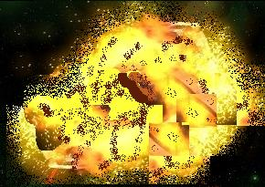The Maquis ship, probably not even knowing what had hit it and not able to do anything to stop it, began to rip apart from the inside. The trilithium bomb exploded its innards, starting at the internal warp coils. In a matter of just a few moments, the small Maquis ship became nothing more than a field of debris floating through space.

