


Life Lines

Concept by: Mark Sickle

Storyline created and written by: Mark Sickle

Based on Gene Roddenberry’s “Star Trek”

This story, and all future stories, are written in grateful memory of the creator of the greatest space adventure ever created – Gene Roddenberry.

(2001)

Episode 1

Lessons Learned

Underway: 04/22/01

Prologue

I wasn’t particularly excited about being stationed on the medical ship Mercy. I have always wanted to be sent to a starship as part of the sickbay staff, or even to an outpost. But not to a ship whose sole purpose was purely as a medical facility. At least on an outpost, I would get to experience different aspects of life as a Starfleet officer, and not just my medical training.
Still, as long as I get to practice medicine, I will be happy. It’s all I’ve ever wanted to do.
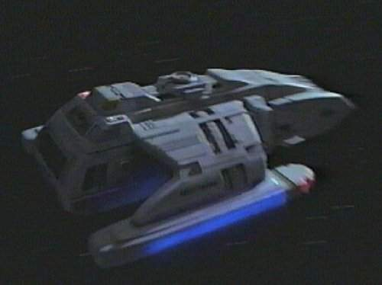
I looked around me and sighed, as much as in boredom as in frustration. The runabout was larger than most shuttlecraft I had ever been in, but still small enough that a 6-hour trip in one could make me go stir crazy.

Sitting across from me was the tall, lean woman I had met back on Starbase 210. She had introduced herself as Chief Tamara Nance, and except for the extended silence between us over the last few hours, her personality was as fiery as the color of her auburn hair. She had told me that she was also reporting to the Mercy, and both of us would board the ship for the first time.
The truth was that I found her attractive. She was very beautiful, with her long, curly hair cascading down over her shoulders, and the way she moved was so graceful.
“So, Tamara, where are you from?” I asked, searching for a good conversation started (and failing miserably).
“With all due respect, sir, but I’d rather if you called me Chief Nance!” she said, rather harshly.
I just looked away and mouthed “Okaaayyy….” Her attitude took me aback, but at the same time, she was not disrespectful. Just firm – solid in her ways.
“And, to answer your question, I’m from Queensland…”she finally said, after the moment of awkward silence following her marked defiance of congeniality.
“Australia? Beautiful place…” I commented. It was the truth – I loved it there.
She looked at me in somewhat of a disbelieving glare. “You’ve been to Australia?”
I nodded my head. “A couple of times. Used to vacation there all the time.”
“Hmmmm. Okay, so where do you call home?” she asked.
“I was born and raised on a starbase. Spent my whole life there, until recently, putzing around only half a sector away from Romulan space.”
She scowled. “That must not have been fun,” she replied, only half listening to him.
“Neither is this runabout ride. How long till we get there anyways?”
She checked the navigation board. “Another hour and 7 minutes,” she replied.
She casually glanced back at the sensor logs as well, and then suddenly shot straight up in her chair. “I’m detecting an energy fluctuation in the port side nacelle,” she stated. “I have to drop us out of warp…”
I sat up as well, my interest piqued. I don’t know anything about engineering, but I’m always willing to learn something new. “What can I do?” I asked.
“I’m not even sure there’s much of anything I can do. Hold on, I think I’ve got it fixed, but I have to…” she started to say.
The runabout was suddenly thrown sideways as a small explosion tore through the nacelle. A visible stream of pink and red gas began to trail behind the small ship as she began to spin out of control.
Chief Nance merely looked at me and said, “I can barely stabilize her. I’m losing control – we’re going to have to find a place to set her down.”
I may not know anything about engineering, but I do know how to operate short-range sensors. “There’s a class M planet less than half a parsec away. Can you get us there?” I asked.
Through the vibrations of the gyrating runabout, she looked over her shoulder and yelled, “I think I can.”
The limping runabout barely made it into orbit, where the chief was able to regain control of the craft. But just when we thought we could relax and try to fix the darn thing, Nance looked at me with a stern face.
“We don’t have enough power to maintain orbit, and now that I’ve shut down that nacelle, I won’t be able to control us enough to land on the surface. I could probably fix it if I had more time.”
I looked at her with a blank stare, kind of like a Barullian deer caught in the headlights of a shuttlecraft. “How long do we have?”
She took a look at her control panel. “Maybe 7 minutes – and I need at least an hour. We’ve already begun losing altitude.”
“Why don’t we just grab some supplies and beam down to the surface?” I suggested.
She shook her head. “This is one of the older versions of the runabout, and they weren’t outfitted with the transporters.”
“So what are you telling me?” I asked.
Her face became pale and grim. “I’m telling you we’re going to have to crash this thing…!”

