Chapter Three

Somewhat confused now, Captain Tyrelle turned to Commander Tyler. “Why would they launch the life pods empty?”
The first officer shrugged his shoulders. “It doesn’t make sense. I don’t think that they did…”
The captain turned around and pondered the situation for a moment. “Get Starfleet on the line. I want to talk to Admiral Ross about this one.”
A few minutes later, the communications officer called out, “Sir, I’ve got the admiral on the line.”
“Onscreen.”
The tired face of Admiral Ross appeared on the viewscreen, rubbing sleep out of his eyes. His hair was amuck, and his uniform no longer looked clean and pressed, but wrinkled and ragged.
“Sorry to wake you admiral.”
The admiral waved his hand in a nonchalant gesture. “Don’t worry about it – I don’t think any of us will get much sleep anyways until this war is over. What have you found, Tyrelle?” he asked.
Captain Tyrelle proceeded to explain about the two starbases, the destroyed ship, the empty lifepods, the lack of any survivors. Everything they had discovered, or hadn’t discovered, to be more precise.
“Every corner we turn gives us new questions, and no answers, admiral. We did find out one thing, though – it appears that the Breen have apparently formed an alliance with the Dominion.”
Admiral Ross simply nodded his head. “We just found out ourselves. Two of Sisko’s officers were abducted by a Breen ship on its way to meet with the Weyoun controlling Dominion operations in the area. They escaped, though, and just got back to DS9 to alert us.”
“What are your orders, now admiral?” the captain asked.
“Keep investigating. Use every method at your disposal. Something’s going on, and we have to find out what. Starfleet is not only losing starships at an alarming rate, but now it appears that we’re also losing personnel. Find them…”
“Understood, admiral. Endeavor out.”
The captain turned to face Commander Tyler. “Commander, why don’t you go down to Sickbay and see if our starbase survivor is awake yet.”
“Aye sir.” The commander stood up and walked across the bridge, disappearing into the turbo-lift.

---------------------------------------------------

Sickbay was nearly empty, with only a few nurses running around the chief medical officer already attending to the starbases sole survivor. Doctor Llalik was getting ready to apply a hypospray to the man’s neck when the commander walked up behind her.
“How is our guest?” he asked.
She frowned, and glanced up at him. “He’s in a lot of pain. He can speak with you, but his tongue and trachea were badly burned in the attack. He may not be able to talk much…” she said.
Tyler looked down at the young man lying there. The man’s face was charred black, and in some places still bleeding a little bit. His red and black uniform was ripped and marred with blood and dirt. He was a kid, young and scared, that much Tyler could see. He remembered the kids name was Jacen.
The survivors eyes focused on him. “My name is Commander Damien Tyler. How are you feeling?”
The man made a guttural noise with his throat before barely getting out, “It hurts…”
Tyler nodded his head in understanding. “I know. Doctor Llalik is going to take real good care of you. Can you tell me something about what happened?”
Jacen’s eyes glazed over, as he tried to remember the attack. “They came out nowhere, and hit us with some sort of energy displacement weapon. All of our systems went crazy, then just died. They they just pounded on us. Last thing I remember was the explosion right over me, and the metal beam falling on me….”
It was obvious to Tyler that talking pained the man, but he had to get answers. “What happened to the others?”
Using his voice became more strained, and he tried to sqeeze out the answer. “They…. were…… taken…..”
“Do you know where?” Tyler asked.
The man, unable to speak anymore, nodded his head negatively. “Okay, son. Just hang in there, okay?”
The injured man laid his head back, closing his eyes in an effort to shunt away the pain he was feeling. Tyler was sympathetic to the man, but he had to get back to the bridge.
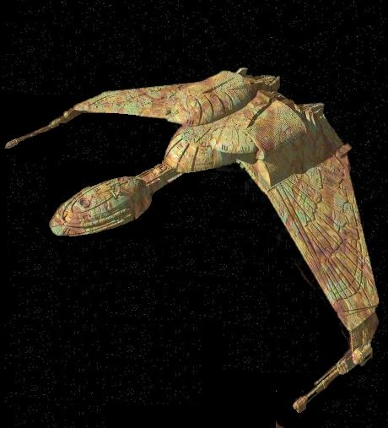
- Onboard the Klingon Bird of Prey B’Mort

It was a good target – alone, isolated, and afraid. Their prey was just
sitting there, asking to be attacked. And it was theirs for the taking, the smell of victory wafted around the small cramped bridge, making all of them anxious to get it over with so that they could savor the moment.
“We are still cloaked,” came the hissed response from behind him.
The Klingon commander merely scowled. “Scan them…”
The order was carried out. “They are alone, and defense shields are
not active…”
It was decided then. Victory would be their’s, and they would bring
honor to the Empire. “Transfer energy to the weapons and disengage cloak…”
The Klingon bird of prey revealed itself by decloaking, and began an
attack run on the small Jem’Hadar scout ship.
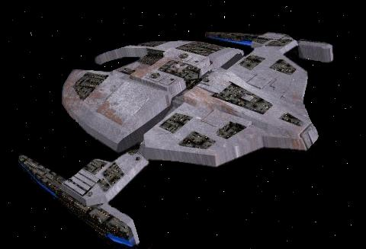
Suddenly, the sensors screamed from all over the bridge, desperately trying to gain attention. They succeeded.
“Sensors detect 5 Jem’Hadar warships closing in on us, weapons armed!”
The Klingon commander whipped around and glared into the eyes of his science officer. “Where did they come from?” he snarled.
“I do not know. But they are attacking…”
The Klingon commander turned back to the viewscreen and watched as the Dominion’s premier warships circled around them and began to fire on his ship. “Perhaps today is a good day to die! Fire all weapons!”

----------------------------------------------------

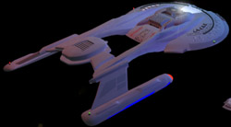
- Back onboard the USS Endeavor

“Captain, there’s a distress signal from the Klingon ship B’Mort point seven five light years from here..!”
“Intercept course, now! How long?”
“Six minutes, sir…”
Commander Tyler exited the turbo-lift a few minutes later and came
down to the command center, taking a seat next to the captain. “What did I miss?”
Captain Tyrelle glanced over at Tyler. “We’re on an intercept for the Klingon bird of prey B’Mort. She was patrolling the DMZ near here and just reported being under attack.” He looked up the navigation station. “How long now?”
“We’re within sensor range now. Scanning…. I count 6 Jem’Hadar ships fleeing back across the border – looks like we scared them off.”
The sensors were then focused on the Klingon ship, rather than the enemy vessels running away. “The B’Mort is drifting, engines off line, shields down. Sensors indicate 12 lifesigns…”
“Shall we pursue the Jem’Hadar?”
The captain snapped back, “No, we have to give the Klingons whatever help we can. Begin transporting the survivors directly to Sickbay, and alert Doctor Llalik that they’re coming.”
Commander Tyler shot a glance back at the tactical officer. “Track those Jem’Hadar ships – we don’t need them swinging back here to finish their job and hit us too.”
The black officer sitting at OPS turned and looked over his shoulder. “Sir, the transporter room reports that all survivors are aboard.”
“Alright. T’Shanik, where are the Jem’Hadar?”
“This is odd, sir, but I can’t find them. It’s as if they cloaked -- sensors can’t find any of trace of them.”
The captain was at a loss. “Now what the hell do we do?” he said. It was clear to everyone on the bridge that he was frustrated.
Commander Tyler looked over at the captain. “Sir, I had a thought – can we speak in private?”
With a somewhat annoyed glance, Captain Tyrelle gruffly replied, “In my ready room, now!”
The two officers got up, and as the exasperated captain stalked into his personal office, which lay right off the bridge, the commander followed close behind.
Once the doors had closed behind them, Captain Tyrelle spun around and allowed his anger to explode. “What the Hell is your problem? I thought I made it clear at the beginning that I am in command here, not you!”
“All due respect sir, but you need to calm down. We’ve got a real problem here, and you don’t know how to proceed. I’ve got options for you. And yelling at me because you’ve got some kind of dumb vendetta against me from years ago is NOT going to solve this problem!” Tyler yelled back.
The captain didn’t calm down, but he didn’t say anything else back at first. His face had visibly turned red. “What options – let’s have them, and they better be good…”
“Well, really only one option. I have hunch about what’s happening here, but to back it up, I have to do some undercover work.”
“You’re crazy. If you think I’m going to let you go off on some half-cocked mission just because….” The captain started.
“Remember what the admiral said, captain? ‘Use every method at your disposal’. I’m assuming that they expected some one to have to go undercover, or else they wouldn’t have sent somebody with my background in Intelligence.”
Now the captain seemed to settle down a little. “What did you have in mind?” He walked over and sat down behind his desk, crossing his legs.
“I’d like to contact a friend of mine who still works with Intelligence. With any luck, he’ll have some more information he can give us that will help us get to the bottom of this.”
Captain Tyrelle sat there and contemplated what he had just been offered. “What do you need to do, and how can I help?”
Tyler walked up to the desk and rested his knuckles on the edge. “I’ll need to contact him on a secure channel, and we’ll set up a meeting with him somewhere near here.”
“Okay, what else?”
“I’ll need to take a runabout, disguised as non-Starfleet vessel, and a two man away team with me.”
At that, the captain merely scoffed. “You can have the runabout, but you will absolutely not get my crew…”
Commander Tyler began to lose his temper, finally. “Look, captain, if my suspicions are correct, we may not have a whole lot of time. I think we might be facing a new threat to the Alpha quadrant that we’re not prepared to handle. Now, do you want to be responsible for the destruction of everything we know just because you won’t lend me two of your officers?”
For a moment, it looked as if the captain was going to lose his temper again, but then he merely swallowed hard. “Fine, take two people. I’ll authorize for you to take one runabout, and Lt. Lewis will take off the markings. Get your away team, and your stuff, and get out of here.”
Commander Tyler merely nodded his head, still angry at the way he had been treated by Captain Tyrelle from the minute he had come aboard. He turned on his heel and walked out of the ready room.
Captain Tyrelle merely glared at the commanders back as he walked away. Once the doors had shut, he muttered, “I hate that man.”

Tyler retired to this temporary quarters where he had stashed his personal belongings when he came aboard. He went straight over the to the desk computer terminal and activated it.
“Computer, prepare message to be sent as Priority Alpha One,” he said quietly.

The female computer voice responded to him. “Please state security clearance for verification…”
“Security clearance Tyler two-two-Beta-nine.”
The computer spent several seconds registering and verifying the code. “Security clearance accepted. Priority Alpha One has been set – secure channel open.”
He took a deep breath before sending out the message. Making sure it was coded for a secure channel was easy -- getting past the sensor relays was not. But he knew how to do it. It was simple message that he was sending out, meant for the eyes of only one person.
And only one person would read it. Whether or not somebody else would be informed as to its contents was not the issue. More than likely, it would be relayed to a supervisor. Right now, Tyler didn’t care about that, though. All he cared about was finding answers, and the man he was calling would be the right place to start.

